Basic Auth – E2E Security Posture
Author: Benjamin Soto-Roberts
Created: June 9, 2026


Introduction

Purpose
This project serves as a training and portfolio exercise designed to simulate a production-grade authentication component. In a real environment, this service would act as an internal authentication layer responsible for enforcing RBAC and securing subsystem access.

Audience
This document is intended for developers, security engineers, and internal stakeholders responsible for maintaining or integrating with the authentication service.

Scope

In Scope
- HTTP Basic authentication
- Role-based access control (RBAC)
- Secure endpoint protection
- Proper HTTP status codes and response headers
- Security behavior testing (shift-left approach)
- Layered security
- Brute-force and rate-limit protections
- Input validation

Out Of Scope
- User registration
- JWT / token-based auth
- Refresh tokens
- STATEFUL sessions
- PUT/POST/PATCH/DELETE Methods

Overall Description

2.1 Overview
The REST API consists of two read-only endpoints protected by RBAC. The standard user endpoint requires successful authentication and a USER role, returning the authenticated user's non-sensitive profile data (username and roles). The admin endpoint requires successful authentication and an ADMIN role, returning a list of all users and their respective roles.

2.2 User Personas
Persona | Description
ANONYMOUS | Any unauthenticated or unsuccessfully authenticated client. No access granted.
USER | An authenticated principal with a standard USER role. Restricted access to designated endpoints.
ADMIN | An authenticated principal with a privileged ADMIN role. Access to all available endpoints.

2.3 API Contract
Method | Endpoint | Description | Auth Required | Role Required
GET | /api/me | Returns the authenticated user's non-sensitive profile details and granted roles | YES | USER/ADMIN
GET | /api/admin/users | Returns a list of all users | YES | ADMIN

Requirements

3.1 Functional Requirements
FR-1. When a client sends a valid HTTP Basic Authorization header with valid credentials linked to a standard user level protected endpoint, the server authenticates the client and returns a 200 OK status with the user’s non-sensitive profile details and granted roles.
FR-2. When a client sends a valid HTTP Basic Authorization header with valid credentials linked to an admin user role to an admin user level protected endpoint, the server authenticates the client and returns a 200 OK status with all user’s non-sensitive profile details and granted roles.
FR-3. When an anonymous user sends a valid HTTP Basic Authorization header with invalid credentials to a protected endpoint, the server rejects the client and returns a 401 Unauthorized status and a standardized problem detail response.
FR-4. When a client sends a valid HTTP Basic Authorization header with valid credentials linked to a standard user role to an admin user level protected endpoint, the server authenticates the client and returns a 403 Forbidden status after authorization checks with a standardized problem detail response.

3.2 Non-Functional Requirements
NFR-1. Response times must not exceed 100 ms under normal operating conditions.
NFR-2. The API must enforce HTTPS. Plaintext HTTP requests must be rejected with HTTP 421 (Misdirected Request). The server must only accept connections on port 443. HSTS (Strict-Transport-Security) must be applied to all responses.
NFR-3. All authentication events must produce a structured log entry containing: outcome (success/failure), username, timestamp (ISO 8601), and source IP. Log entries must not include plaintext credentials. Source IP fields must be treated as PII in accordance with applicable data handling policy.
NFR-4. Passwords must be stored as one-way hashes using Bcrypt with a minimum work factor of 12. Passwords are never stored in plaintext or using reversible encryption.
NFR-5. All error responses must conform to IETF RFC 9457 (Problem Details for HTTP APIs).
NFR-6. All database connections must use a dedicated, least-privilege role. This role must be scoped to only the permissions required for authentication operations. Root or superuser database credentials must never be used by the application.
NFR-7. The API must enforce a rate limit on authentication attempts per source IP. After a configurable threshold of consecutive failed attempts, the source IP must be temporarily blocked and a 429 Too Many Requests response returned.
NFR-8. Credential input (username and password) must be validated for maximum length and acceptable character sets prior to processing. Requests exceeding defined input limits must be rejected with 400 Bad Request.

Standards
RFC 9457: Problem Details for HTTP APIs | RFC Editor
RFC 9110: HTTP Semantics | RFC Editor

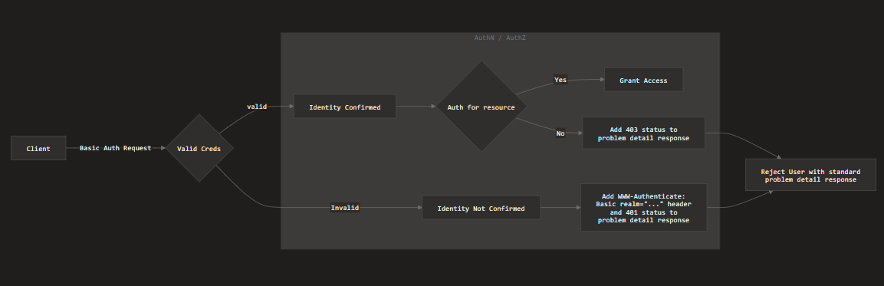
The client makes a request to a uri with basic authentication header for http basic authentication.
The request flows though the Custom Authentication Entry point and returns a 401 problem detail response for unauthenticated attempts.
The request matchers enforce RBAC by checking for endpoint requirements and t
